NAME……………………………………………INDEX NO………………………………
ADM NO…………….CLASS………..
CANDIDATE’S SIGN…………………………. DATE…………………………………….
SCHOOL……………………………………………………………………………………….
231/2
BIOLOGY
PAPER 2
THEORY
JULY2026
TIME: 2 HOURS
R.C.E. A JOINT EXAMS
Kenya Certificate of Secondary Education (K.C.S.E)
231/2
BIOLOGY
PAPER 2
THEORY
JULY 2026
TIME: 2 HOURS

INSTRUCTIONS TO CANDIDATES.
1) Write your name and index number in the spaces provided above.
2) Sign and write the date of examination in the spaces provided above.
3) This paper consists of section A and B.
4) Answer ALL questions in section A in the spaces provided above.
5) In section B answer questions 6 (compulsory) and either question 7 or 8 in the spaces provided after question 8.
FOR EXAMINERS’ USE ONLY.
SECTION | QUESTIONS | MAXIMUM SCORE | CANDIDATES SCORE
A | 1 | 8
A | 2 | 8
A | 3 | 8
A | 4 | 8
A | 5 | 8
B | 6 | 20
B | 7 | 20
B | 8 | 20
B | TOTAL | 80

This paper consists of 8 printed pages.
Candidates should check the question paper to ascertain that all pages are printed as indicated and no questions are missing.

1. The diagram below shows some components of a light microscope.
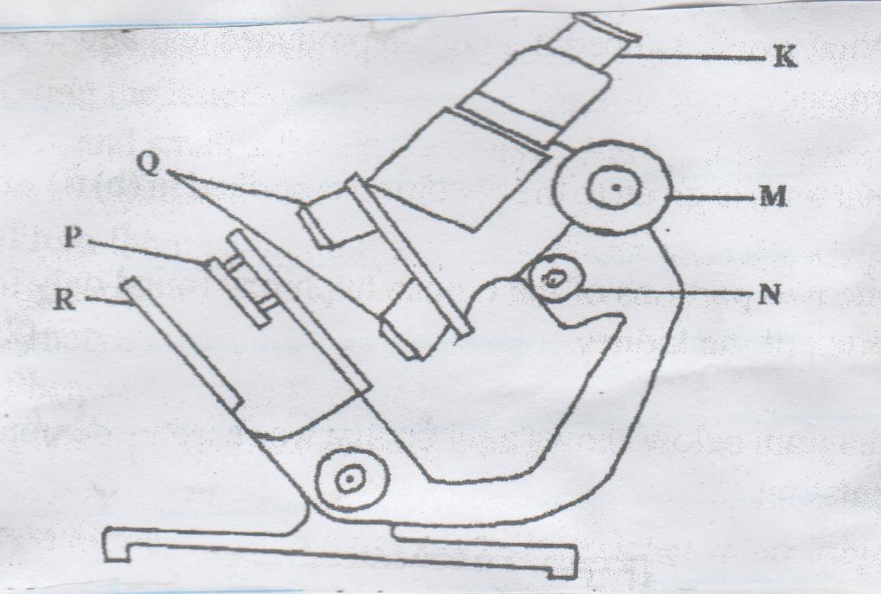

a), Name the parts labeled 1mks
K –
M –
b), State the functions of 2mks
P –
Q –
c) A student was viewing a prepared slide of a plant cell under high power microscope. The features of the cell were blurred. Which one of the labeled parts of the microscope would the student use to obtain;-
(ai), A sharper outline of the features 1mk

ii), Give the formula used to calculate magnification in a light microscope 1mk

d), A student was preparing a section of a plant cell to be viewed on a light microscope. Give a reason for each of the following steps.
i), Cutting a very thin section 1mk

ii), staining the section 1mk

iii), Putting the section in water. 1mk

2. Haemophilia is a sex linked disorder due to a recessive gene. A carrier woman married a normal man. Let H represent gene for normal condition and h to represent gene for haemophilic condition.
a), State the genotypes of
i), Man 1mk

ii), woman 1mk

bi), Using a punnet square, show the genotypes of the children resulting from this marriage 3mks

ii), State the probability of getting a carrier daughter. 1mk

c), Give an explanation why haemophilia is more common in males than in females. 2mks

3. In an experiment a group of students set up the test tubes as shown below
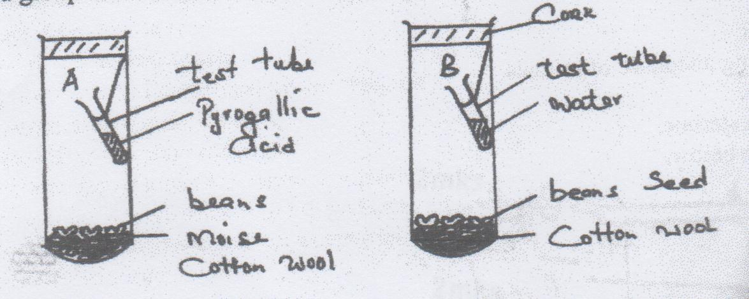

a), What was the aim experiment? 1mk

b), Why was pyrogallic acid included in the gas jar. A? 1mk

c), What results would you expect in each of the gas jar A and B at the end of experiment? 2mks

d), State two artificial ways of breaking seed dormancy. 2mks

e), Name two harmones that bring about rapid cell division in plants 2mks

4. a. i), Distinguish between single circulatory system and closed circulatory system. 2mks

ii), Name the blood vessels that transports blood from
a), small intestines to the liver 1mk

b), Lungs to the heart 1mk

bi), Name one defect of circulatory system in humans. 1mk

ii), State three functions of blood other than transport. 3mks

5. An experiment was set up to demonstrate the necessity of carbon (IV) oxide for photosynthesis in a certain green plant as shown below. The plant was first kept darkness for 48 hours before the experiment.
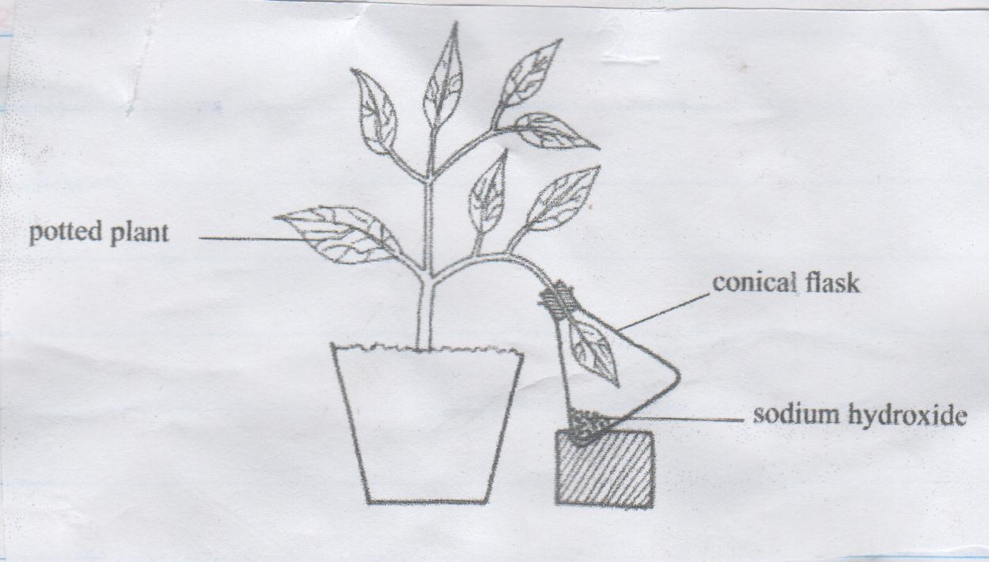

a), Why was the plant kept in darkness for 48 hours before the start of this experiment. 1mk

b), What was the role of sodium hydroxide? 1mk

ci), What happened to the leaf in the flask when it was tested for presence of starch after the set up was exposed to light for a day?. 1mk

ii), Give reasons for your answer in (c) I above 2mks

d. Suggest a control for this experiment. 1mk

e), Name other two limiting factors in this experiment. 2mks

SECTION B 40MKS

Answer question 6 (Compulsory) and either question 7 or 8 in the spaces provided after question 8.
6. A certain experiment was performed to demonstrate the effect of sweating on human body temperature. Boiling tubes A and B were filled each with water their initial temperatures recorded. This was repeated after every 5 minutes. The surface of tube A was continuously wiped with a piece of cotton wool which had been soaked in methylated spirit. The results are as shown below

Time (min) | Temperature 0^{c} in tube
 | A | B
0 | 80 | 80
5 | 54 | 67
10 | 40 | 59
15 | 29 | 52
20 | 21 | 47
25 | 18 | 46

a), On the same axis, plot graphs of water temperature against time (min) 8mks

b), Find the rate of cooling in A 1mk

c), Why was test B included in the set up? 1mk

d), Name two ways through which heat is lost in tube B. 2mks

e), State the expected results if tube A was insulated. 1mks

f), Name the structures in the following organisms that would insulate heat loss.
i), Birds 1mk

ii) Mammals 1mk

g), Name any two receptor cells on the skin of man. 2mks

h), Describe the response of hair on the skin during cold weather. 3mks

7. a) Describe gaseous exchange in alveolus. 8mks
b) Describe the process of exhalation in mammals. 8mks
c) Discuss the characteristics of gaseous exchange sites in an animal. 4mks
8. Discuss the nitrogen cycle. 20mks

